**EXP NO: 18 Extracting Browser Artifacts NAME : ADHIYAN PERIYAR R P**

**DATE: 25/09/2025 ROLL NO : 231901002**

**Aim :**

How to Extracting Browser Artifacts

**Procedure :**

* ChromeHistoryView: is a small utility that reads the history data file of Google

Chrome Web browser, and displays the list of all visited Web pages in the last days.

* For each visited Webpage, the following information is displayed: URL, Title, Visit

Date/Time, Number of visits, number of times that the user typed this address (Typed Count), Referrer, and Visit ID

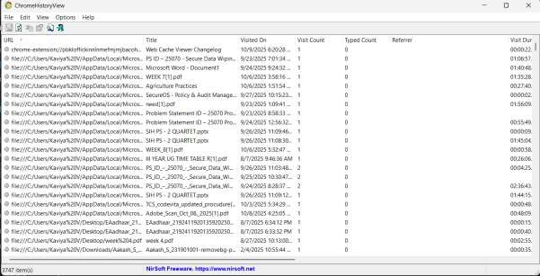

**ChromeCacheView:**

* ChromeCacheView is a small utility that reads the cache folder of Google Chrome Web browser, and displays the list of all files currently stored in

the cache.

* For each cache file, the following information is displayed:

URL, Content type, File size, Last accessed time, Expiration time, Server name, Server response, and more.

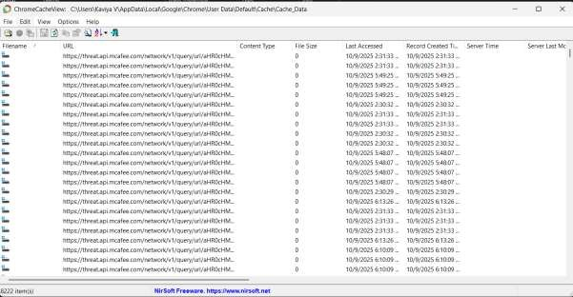

**IEHistoryView**:

* This utility reads all information from the history file on your computer, and displays the list of all URLs that you have visited in the last few days.

* It also allows you to select one or more URL addresses, and then remove them from

the history file or save them into text, HTML or XML file.

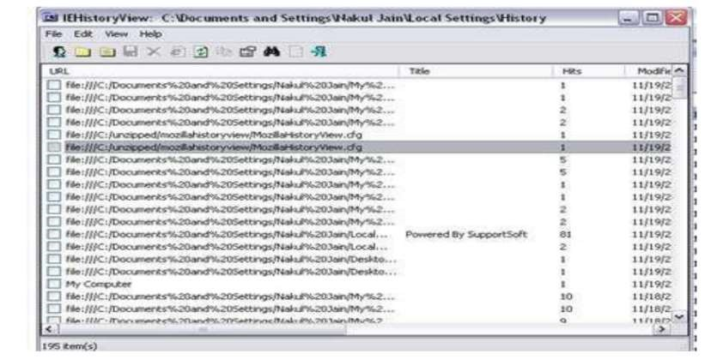

**IEHistoryView:**

* This utility reads all information from the history file on your computer, and displays the list of all URLs that you have visited in the last few days.
* It also allows you to select one or more URL addresses, and then remove them from the history file or save them into text, HTML or XML file.

**IECacheView**:

* IECacheView is a small utility that reads the cache folder of Internet Explorer, and displays the list of all files currently stored in the cache.

* For each cache file, the following information is displayed: Filename, Content Type, URL, Last Accessed Time, Last Modified Time, Expiration Time, Number of Hits, File Size, Folder Name, and full path of the cache filename.

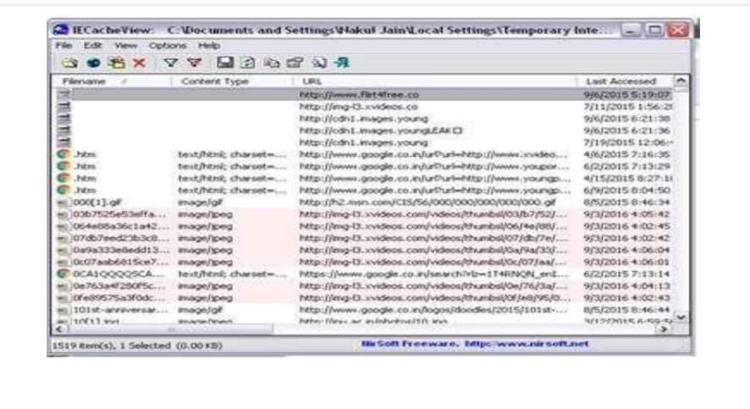

**Result:**

Thus, the forensic tools executed successfully, and the evidence was captured and analyzed accurately.